### **Low-Level Overview:**

**1. Vendor based login**

Vendor of different types like electra, insurance, internet, tv, mobile will login and redirected to their respective dashboard. For this role based authentication will be implemented from the backend.

They will add their services or products with variable offers and discounts and freebies.

If they have freebies then they will add it using separate form with respective price and discounts if any.

For every vendors there will be an import/export facility to bulk upload/download service details.

Vendor could have links to see its subscribers list and details.

Vendor could have links to see subscription requests with status.

Subscription requests must have payment status to confirm payment.

If payment confirmed and service delivered or installed then the subscription contract will be active against the subscriber according to terms mentioned in the service.

For contract cancellation cancellation status should be shown against each contract. Once cancellation approved consumer should be notified.

For transfer request by the consumer, a transfer approve status should be shown against the contract. Once approved contract should be canceled and notification should be sent to both the consumer and to the new vendor who will provide new service. The new vendor service request status should be active so that the new vendor can proceed for further process. Once the new vendor approves or delivers the service then the customer service contract gets active.

An average rating view would be shown against each service so that vendors can review ratings sent from customers.

**2. Customer login**

Customer need to login in order to apply for a service.

First he will search for a particular service using his area pin code. In the search list all services are compared through ratings, price, discounts and best offer among which two service providers will be shown on top then in the tabular list other services will be shown according to their best service and offers in most popular order.

Customer has to click on proceed button and follow the guidelines to apply for the service. Services here shown may have variable options to choose either of freebies, discounts and offers. Once customer apply for a service a service request will be added to customers My Services list, then there he can request for cancellation or transformation

The Data Flow is as below->

* **Vendor Login and Dashboard:** Vendors of different types (e.g., electricity, insurance, internet, TV, mobile) log in and are redirected to their respective dashboards.
* **Add Services/Products:** Vendors add their services/products with variable offers, discounts, and freebies. If there are freebies, they are added using a separate form.
* **View Subscribers and Subscription Requests:** Vendors can view their subscribers' list and details, as well as subscription requests with status.
* **Manage Subscriptions:** Vendors can manage subscriptions, including confirming payments, activating contracts, and managing cancellations and transfer requests.
* **Customer Login and Search:** Customers log in and search for services based on their area pin code. The system compares services based on ratings, price, discounts, and offers, and displays the results.
* **Apply for Service:** Customers select a service and apply for it, choosing options like freebies, discounts, and offers. A service request is added to the customer's "My Services" list.
* **Manage Services:** Customers can manage their services, including requesting cancellations or transformations.
* **Terms Conditions of Services:** Requiredterms and conditions of service request by customers to preserve cancellation period, approval period etc.

### 3. Real-World Data Flow Diagram (DFD):

Below is a simplified real-world Data Flow Diagram (DFD) for the system:

* **External Entities**:
  + **Users**
* **Processes**:
  + **User Registration/Login**
  + **Quote Generation**
  + **Service Request**
  + **Customer Support**
* **Data Stores**:
  + **User Profiles Database**
  + **Insurance Provider Data**
  + **Policy Data Storage**
* **Data Flows**:
  + **User Input (Personal Details, Coverage Needs)**
  + **Quote Requests (To Vendors/Providers)**
  + **Insurance Quotes (From Vendors/Providers)**
  + **Service Request Data**
  + **Customer Support Interactions**

**4. Overall Simplified DFD:**

**User Interface (Web Platform):** This is the front-end interface where users interact with the platform. They input their requirements and preferences through forms and menus.

**User Input Form:** This is where users enter their criteria for internet and TV services, such as location, desired speed, TV package preferences, etc.

**Data Processor:** Processes the user input, validating it and preparing it for comparison.

**Data Validation:** Ensures that the user input is correct and complete before proceeding to the comparison stage.

**Service Database:** Contains information about various internet and TV service providers, including their packages, prices, features, and terms.

**Comparison Engine:** Compares the available service options based on the user's input and the data from the service database.

**Comparison Result Presentation:** Presents the comparison results to the user in a clear and understandable format, allowing them to make an informed decision.

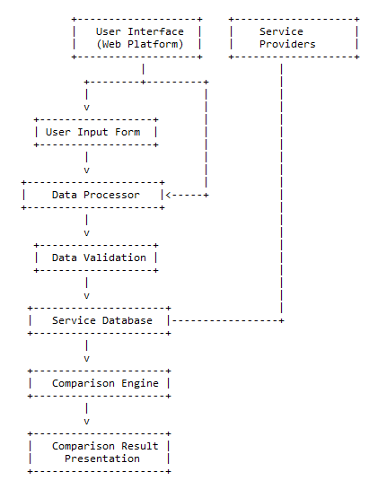

### 5. Additional Queries:

* **Error Handling**: Processes for handling errors, such as failed quote requests or system errors, would also be present in the system.
* **Security Measures**: Secure data transmission, encryption of sensitive information, and compliance with data protection regulations are essential aspects of the system's design.
* **Performance Optimization**: Measures to optimize system performance, such as caching frequently accessed data and load balancing across servers, would be implemented to ensure a smooth user experience.
* **Data Format:** Required a client raw data format before proceeding towards Database Structure.
* **No Direct Involvement of Providers:** As the software facilitates only comparing best offers and prices which is gathered through clients manual entry hence there is no redirection or link to any third party or service providers after a customer submits its requests/requirements.
* **Third Party API Integration:** Any third party API integration for any service changes should be notified during the DB structure.
* **Language Conversion:** Language conversion required from English to Dutch.
* **Additional Filter Algorithm:** There may required additional algorithms in order to choose best items/services/offers considering client’s requirement.